**Day-2 (Assignment-3)**

# **Q)Research and compare SDLC models suitable for engineering projects. Present findings on Waterfall, Agile, Spiral, and V-Model approaches, emphasizing their advantages, disadvantages, and applicability in different engineering contexts.**

#### 1. **Waterfall Model**

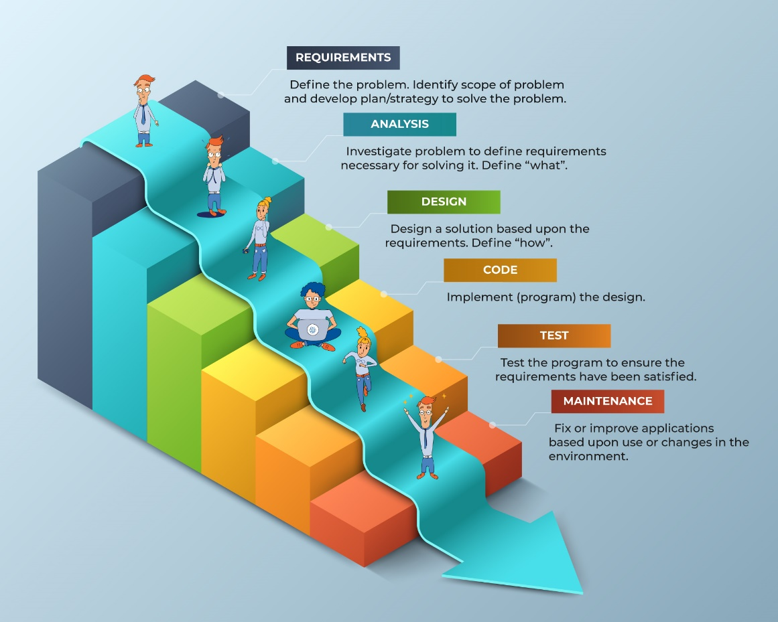**Overview:** The Waterfall model is a linear and sequential approach where each phase must be completed before the next begins. It is one of the earliest SDLC models used in software development.

**Advantages:**

* **Simplicity:** Easy to understand and manage due to its straightforward, linear progression.
* **Documentation:** Comprehensive documentation at each phase ensures clear understanding and traceability.
* **Structured:** Well-defined stages make it easier to manage and control.

**Disadvantages:**

* **Inflexibility:** Changes are difficult and costly to implement once a phase is completed.
* **Late Testing:** Testing occurs late in the development cycle, making early detection of issues challenging.
* **Risk:** High risk if requirements are not well-understood or change during the development process.

**Applicability:**

* Suitable for projects with well-defined requirements and low likelihood of changes.
* Ideal for projects with regulatory or compliance requirements that necessitate thorough documentation.

#### 2. **Agile Model**

**Overview:** The Agile model emphasizes iterative development, where requirements and solutions evolve through collaboration between cross-functional teams. It promotes adaptive planning, early delivery, and continuous improvement.

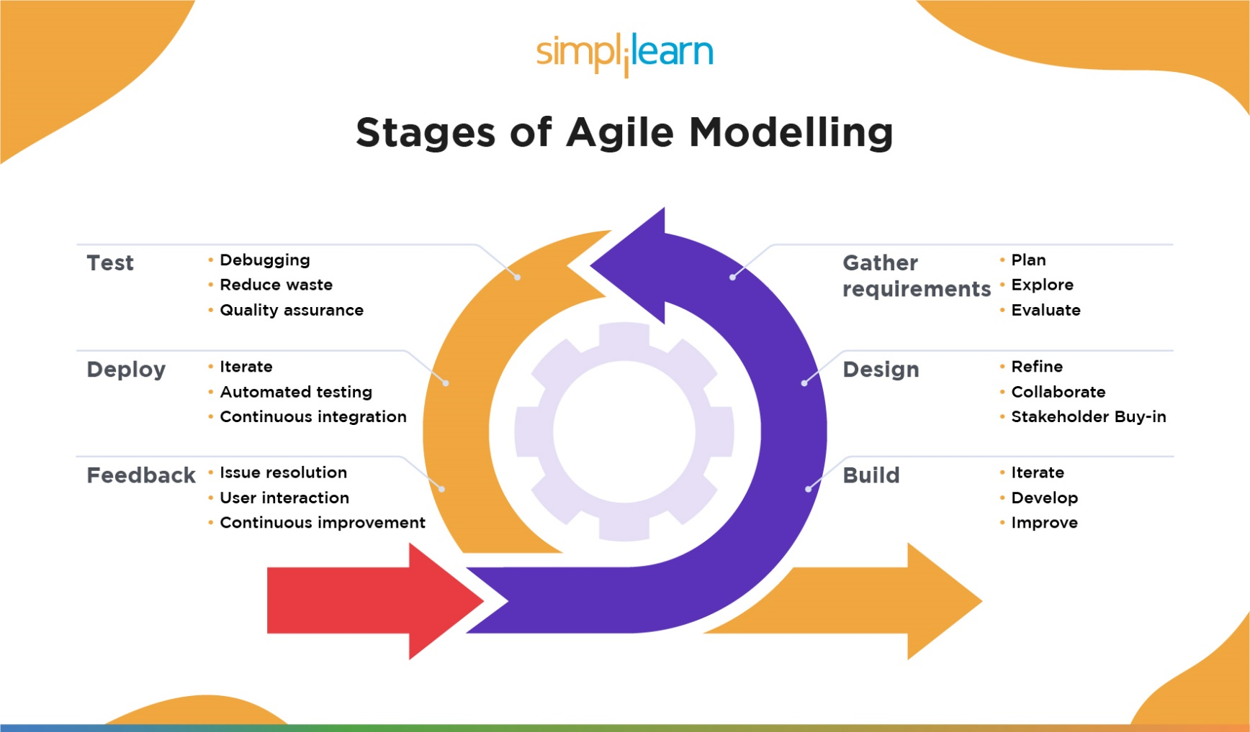

**Advantages:**

* **Flexibility:** Easily accommodates changes in requirements throughout the development process.
* **Customer Involvement:** Continuous customer feedback ensures the final product meets user needs.
* **Early and Continuous Delivery:** Regular releases provide early value and allow for ongoing user feedback.

**Disadvantages:**

* **Documentation:** May lack comprehensive documentation due to the focus on working software.
* **Scope Creep:** Risk of scope creep due to frequent changes and additions.
* **Resource Intensive:** Requires a high level of collaboration and communication, which can be resource-intensive.

**Applicability:**

* Suitable for projects with rapidly changing requirements or those needing frequent releases.
* Ideal for environments where customer feedback is crucial and can be regularly obtained.

#### 3. **Spiral Model**

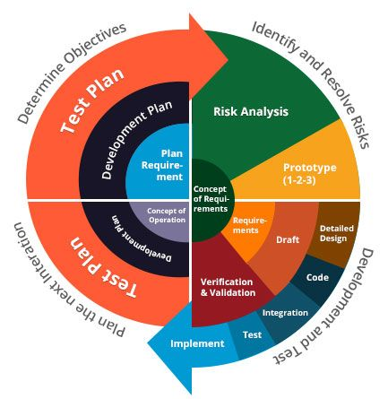**Overview:** The Spiral model combines iterative development with systematic aspects of the Waterfall model, emphasizing risk analysis. It involves repeating a set of activities for each phase in spirals, gradually refining the product.

**Advantages:**

* **Risk Management:** Explicit focus on identifying and mitigating risks early in the development process.
* **Flexibility:** Combines iterative development with structured phases, allowing for adjustments based on risk analysis.
* **Customer Feedback:** Regular user feedback is integrated into each iteration, improving the final product.

**Disadvantages:**

* **Complexity:** Can be complex to manage due to its iterative nature and emphasis on risk analysis.
* **Cost:** Risk analysis and repeated iterations can be resource-intensive and costly.
* **Documentation:** Requires detailed documentation to manage the iterative cycles and risk assessments.

**Applicability:**

* Suitable for large, complex projects with significant risks and high requirements for reliability.
* Ideal for projects where early identification and mitigation of risks are critical.

#### 4. **V-Model (Verification and Validation Model)**

**Overview:** The V-Model is an extension of the Waterfall model, emphasizing verification and validation at each development stage. It represents the development process in a V-shape, where each phase corresponds to a testing phase.

**Advantages:**

* **Quality Assurance:** Focus on testing and validation ensures high quality and reliability.
* **Structured:** Clear phases with defined deliverables make it easy to manage and control.
* **Traceability:** Each development phase is directly linked to a corresponding testing phase, ensuring traceability.

**Disadvantages:**

* **Inflexibility:** Like the Waterfall model, changes are difficult and costly to implement once a phase is completed.
* **Early Requirements:** Requires well-defined requirements from the start, which may be challenging to obtain.
* **Sequential:** Sequential nature can lead to delays if any phase encounters issues.

**Applicability:**

* Suitable for projects with well-defined requirements and high reliability needs, such as safety-critical systems.
* Ideal for environments where rigorous testing and validation are essential.

### Summary of Findings:

| **Model** | **Advantages** | **Disadvantages** | **Applicability** |
| --- | --- | --- | --- |
| Waterfall | Simple, well-documented, structured | Inflexible, late testing, high risk | Well-defined requirements, regulatory projects |
| Agile | Flexible, customer involvement, early delivery | Documentation gaps, scope creep, resource-intensive | Rapidly changing requirements, customer feedback crucial |
| Spiral | Risk management, flexible, customer feedback | Complex, costly, detailed documentation | Large, complex projects with significant risks |
| V-Model | Quality assurance, structured, traceability | Inflexible, requires early requirements, sequential | Well-defined requirements, high reliability needs |

### 

# **Conclusion:**

## Selecting the appropriate SDLC model depends on the specific context and requirements of the engineering project. Waterfall and V-Model are suitable for projects with well-defined requirements and a need for thorough documentation and validation. Agile is best for projects with evolving requirements and a need for frequent customer feedback. The Spiral model is ideal for large, complex projects with significant risks that require continuous risk assessment and mitigation. Each model has its strengths and weaknesses, and the choice should align with the project's goals, complexity, and risk profile.